HAZARD COMMUNICATION PROGRAM
Container Labeling
The Field Superintendent or Foreman will verify that all containers received for use will be clearly labeled in accord with the requirements of HazCom 2012 and GHS, including a product identifier, pictogram, hazard statement, signal word, and precautionary statements, as well as the supplier’s contact information (including name and address).

The Foreman in each work area will ensure that all secondary containers are labeled with the original supplier’s label or with an alternative workplace label. For help with labeling, see Safety Specialist for the Contracting Division. Examples are Jugs, Aerosol cans and Plastic Containers.

The Corporate Safety Manager or a designated representative will review the company labeling procedures annually and will update labels as needed and/or required.
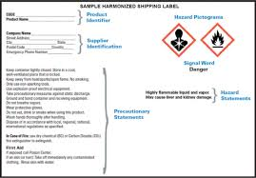
Safety Data Sheets (SDSs)
The Corporate Safety Manager or designated representative is responsible for establishing and monitoring the company SDS program. The procedure below will be followed when an SDS is not received at the time of initial shipment:
- If the SDS sheet is not provided with delivery of the product, the supplier will be notified and a SDS requested for the specific product
- If necessary, the Corporate Safety Manager or designated representative will obtain a SDS via internet and/or other resources.

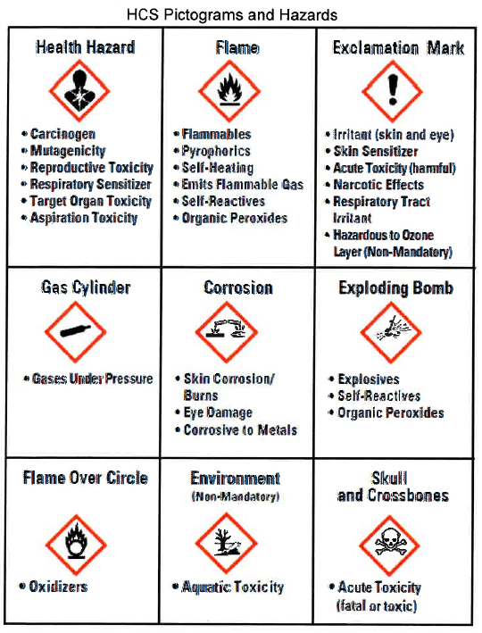
Copies of SDSs for all hazardous chemicals to which workers are exposed or are potentially exposed will be kept on a work computer and/or hard copies in the Foreman’s Supervisors jobsite book. SDSs will be readily available to all workers in each work area during each work shift. If an SDS is not available, contact the Field Superintendent or Foreman immediately. When revised SDSs are received, the old revision will be replaced the most updated revision, all affected employees shall be notified of any potential changes.

The Corporate Safety Manager or designated representative is responsible for reviewing the SDSs received for safety and health implications, and initiating any needed changes in workplace practices.

Employee Information and Training
The Corporate Safety Manager or designated representative is responsible for employee information and training.
Every worker who will be potentially exposed to hazardous chemicals will receive initial training on the Hazard Communication standard and this program before starting work. The training program for new workers is as follows:
- The SDS will be reviewed with the employees that will be handling a hazardous chemical. The recommended PPE will be provided to those handling the chemical.
- An overview of the requirements contained in the Hazardous Communication Standard.
- Hazardous chemicals present at his or her work place.
- Physical and health risks of the hazardous chemical.
- The symptoms of overexposure.
- How to determine the presence or release of hazardous chemicals in his or her work area.
- How to reduce or prevent exposures to hazardous chemicals through use of control procedures, work practices and PPE.
- Steps the employee her taken to reduce or prevent exposures to hazardous chemicals.
- Procedures to follow if employees are overexposed to hazardous chemicals.
- How to read labels and review SDS’s to obtain hazardous information.
- Location of the SDS file and written hazardous communication program.
Prior to introducing a new chemical hazard into any work area, each worker in that work area will be given information and training as outlined above for the new chemical hazard. The training format will be as follows:

Hazards of Non-routine Tasks
Periodically, workers are required to perform non-routine tasks that are hazardous. Examples of non-routine tasks is: confined space entry or changing of propane cylinder on forklifts. Prior to starting work on such projects, each affected worker will be given information by the Field Superintendent or foreman about the hazardous chemicals he or she may encounter during such activity. This information will include specific chemical hazards, protective and safety measures the worker should use, and steps the company is taking to reduce the hazards, including ventilation, respirators, the presence of another worker (buddy systems), and emergency procedures.

Informing Other Employers/Contractors
It is the responsibility of the Corporate Safety Manager or designated representative to provide contractors with information about hazardous chemicals that their workers may be exposed to on this work site, and suggested precautions for workers. It is the responsibility of the Corporate Safety Manager or designated representative, to obtain information about hazardous chemicals used by other employers to which our workers may be exposed.
In addition to providing a copy of an SDS to a contractor, the contractor will be informed of necessary precautionary measures to protect workers exposed to operations performed by FSR.
Also, contractors will be informed of the hazard labels used by FSR. If alternative workplace labeling systems are used, the contractors will be provided with information to understand the labels used for hazardous chemicals to which their workers may have exposure.

List of Hazardous Chemicals
A list of all known hazardous chemicals will be listed in the Site Specific Plan. This list includes the name of each chemical, and the work area(s) in which each of the chemicals is used. Further information on each chemical may be obtained from the SDSs, located in the Site Specific Plan. When new chemicals are received the SDS list is updated. The hazardous chemical inventory is compiled and maintained by the Corporate Safety Manager or designated representative.

Program Availability
A copy of this program shall be available, upon request, to workers, their designated representatives, and OSHA.

